AI ASSISTED CODING
Name:G.Gouri Shankar
Hall Ticket NO:2303A51012
Batch-01
Lab 4: Advanced Prompt Engineering – Zero-shot, One-shot, and Few-shot Techniques, Chain of Thoughts, Prompt
Chaining, DirecEonal sEmulus prompEng Lab ObjecEves:
- To explore and apply different levels of prompt examples in AI-assisted code generaEon.
- To understand how zero-shot, one-shot, and few-shot prompEng affect AI output quality.
- To evaluate the impact of context richness and example quanEty on AI performance.
Lab Outcomes (LOs):
AQer compleEng this lab, students will be able to:
- Use zero-shot prompEng to instruct AI with minimal context. • Use one-shot prompEng with a single example to guide AI code generaEon.
- Apply few-shot prompEng using mulEple examples to improve AI responses.
- Compare AI outputs across the three prompEng strategies.
Q1. Zero-Shot PrompEng (Basic Lab Task)
Task:
Write a Python funcEon that classifies a given text as Spam or Not Spam using zero-shot prompEng.
Steps:
- Construct a prompt without any examples.
- Clearly specify the output labels.
- Display only the predicted label.
Input:
"CongratulaEons! You have won a free lo‘ery Ecket."
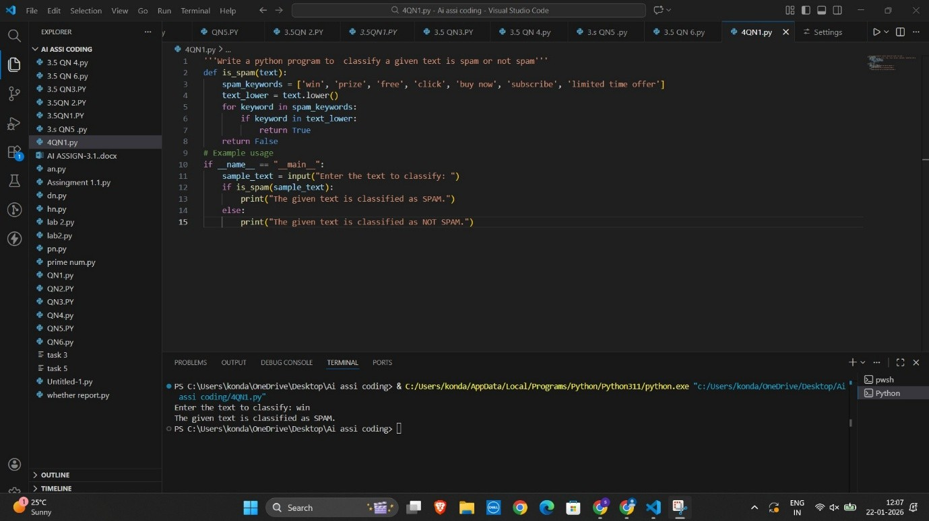
Q2. One-Shot PrompEng (EmoEon detecEon)
Task:
Write a Python program that detects the emoEon of a sentence using one-shot prompEng.
EmoEons: [‘happy', 'sad', 'angry', 'excited', 'nervous', ’neutral’] Steps:
- Provide one labeled example inside the prompt.
- Take a sentence as input.
- Print the predicted emoEon
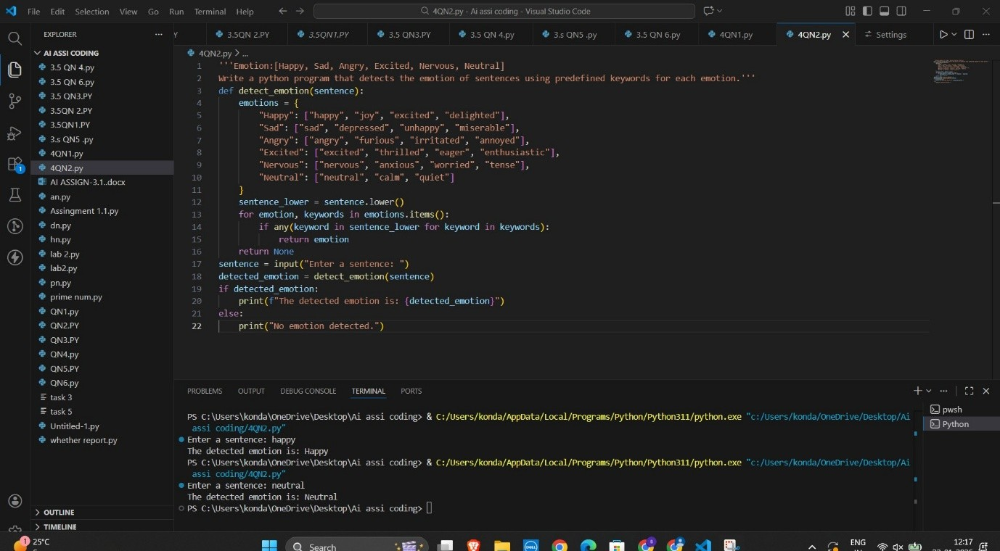
Q3. Few-Shot PrompEng (Student Grading Based on Marks) Task:
Write a Python program that predicts a student’s grade based on marks using few-shot prompEng.
Grades:
['A', 'B', 'C', 'D', 'F']
Grading Criteria (to be inferred from examples):
- 90–100 → A
- 80–89 → B
- 70–79 → C
- 60–69 → D
- Below 60 → F
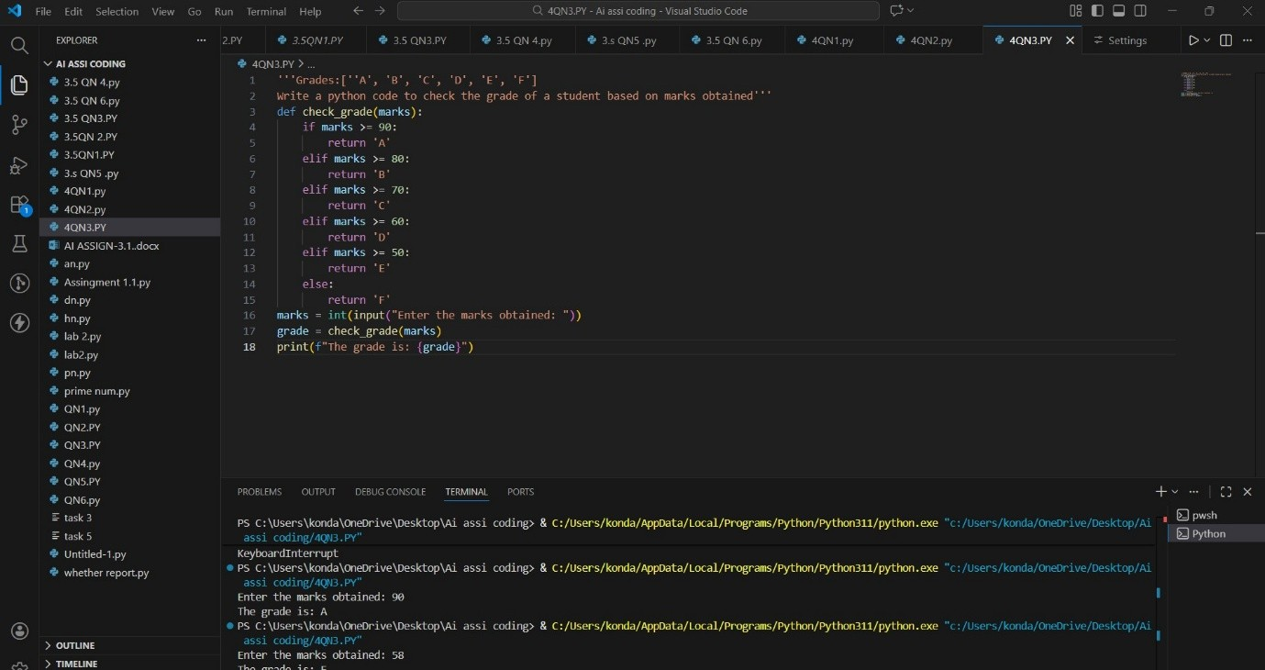
Q4. MulE-Shot PrompEng (Indian Zodiac Sign PredicEon using
Month Name)
Task:
Write a Python program that predicts a person’s Indian Zodiac sign (Rashi) based on the month of birth (month name) using mulE-shot prompEng.
Indian Zodiac Order (Simplified Month-Based Model): The Indian Zodiac cycle starts in March with Mesha and follows this order:
March → Mesha
April → Vrishabha
May → Mithuna
June → Karka
July → Simha
August → Kanya
September → Tula
October → Vrischika
November → Dhanu
December → Makara
January → Kumbha February → Meena
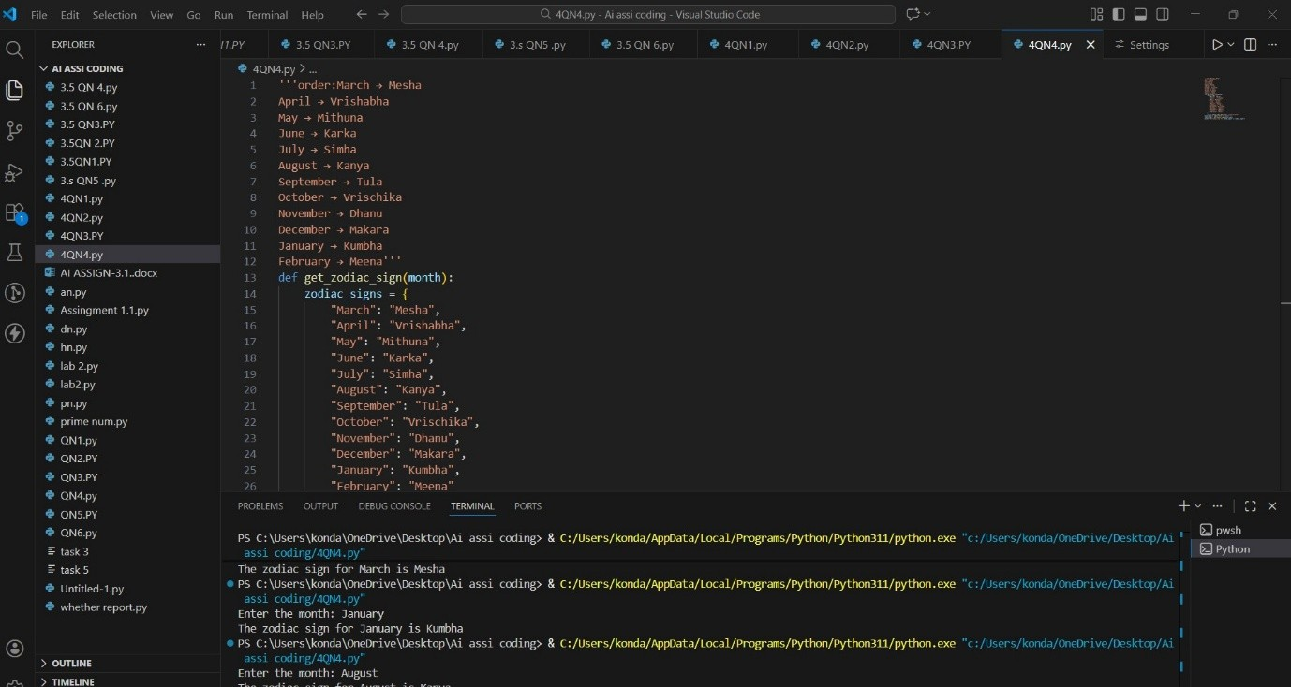
Q5. Result Analysis Based on Marks
Task: Write a Python program that determines whether a student Passes or Fails based on marks using Chain-of-Thought (CoT)
prompEng.
Result Categories:
['Pass', 'Fail']
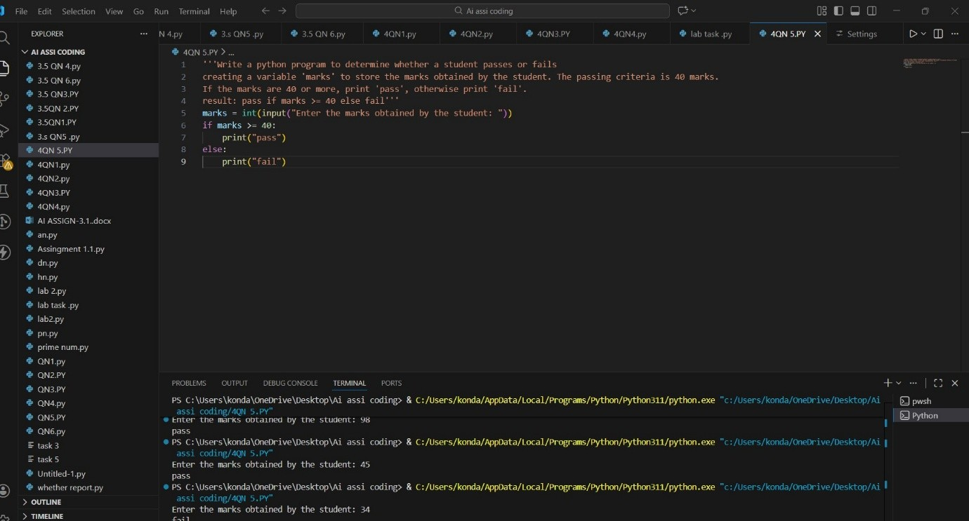
Q6 VoEng Eligibility Check (Chain-of-Thought PrompEng)
Task: Write a Python program that determines whether a person is
eligible to vote using Chain-of-Thought (CoT) prompEng.
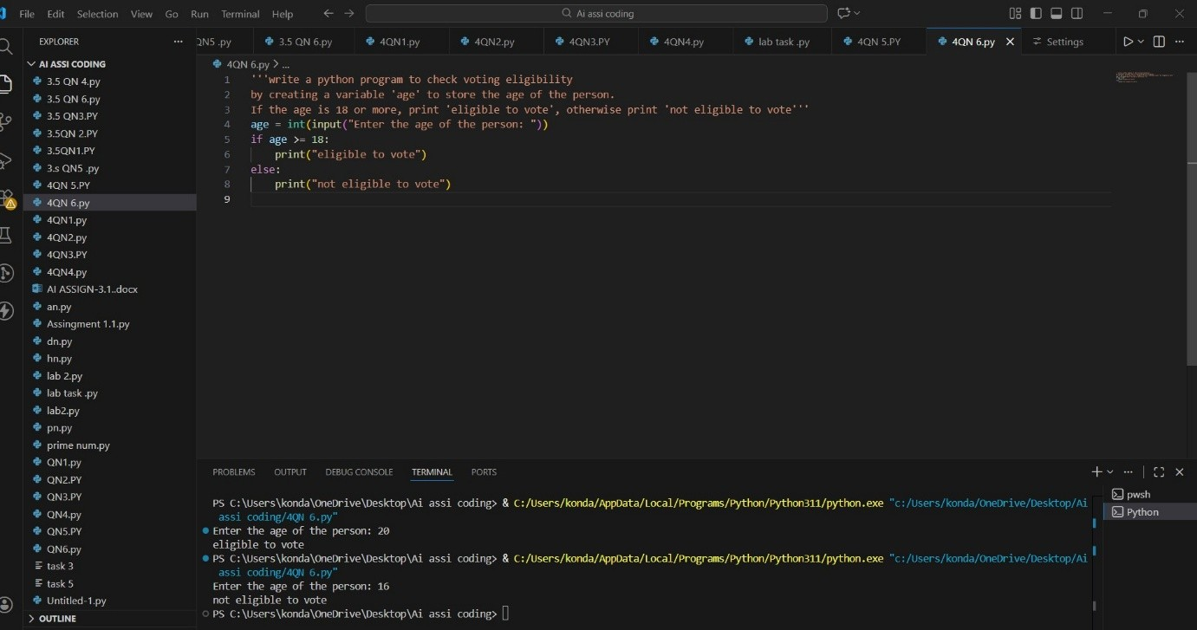
Q7 Prompt Chaining (String Processing – Palindrome Names) Task: Write a Python program that uses the prompt chaining technique to idenEfy palindrome names from a list of student
names.
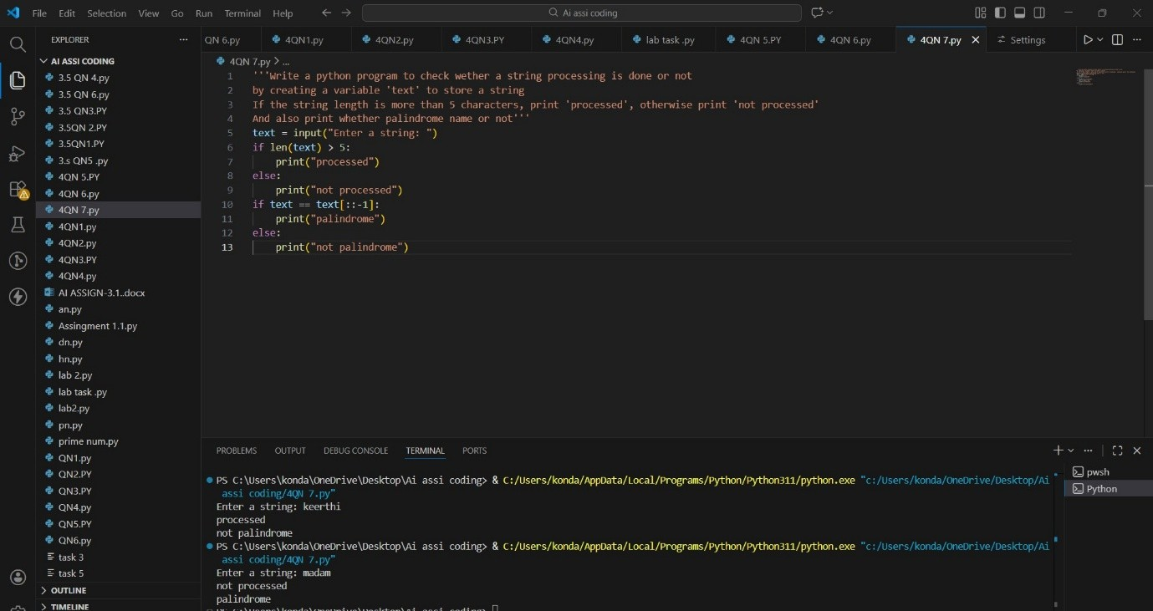
Q8 Prompt Chaining (String Processing – Word Length
Analysis)
Task: Write a Python program that uses prompt chaining to analyze a list of words. In the first prompt, generate a list of words. In the second prompt, traverse the list and calculate the length of each word. In the third prompt, use the output of the previous step to determine whether each word is Short (length less than 5) or Long (length greater than or equal to 5), and display the result for
each word

